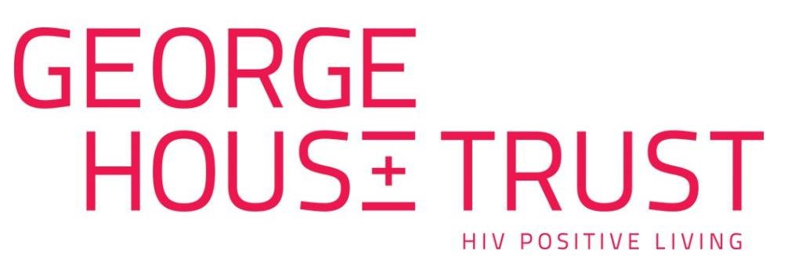
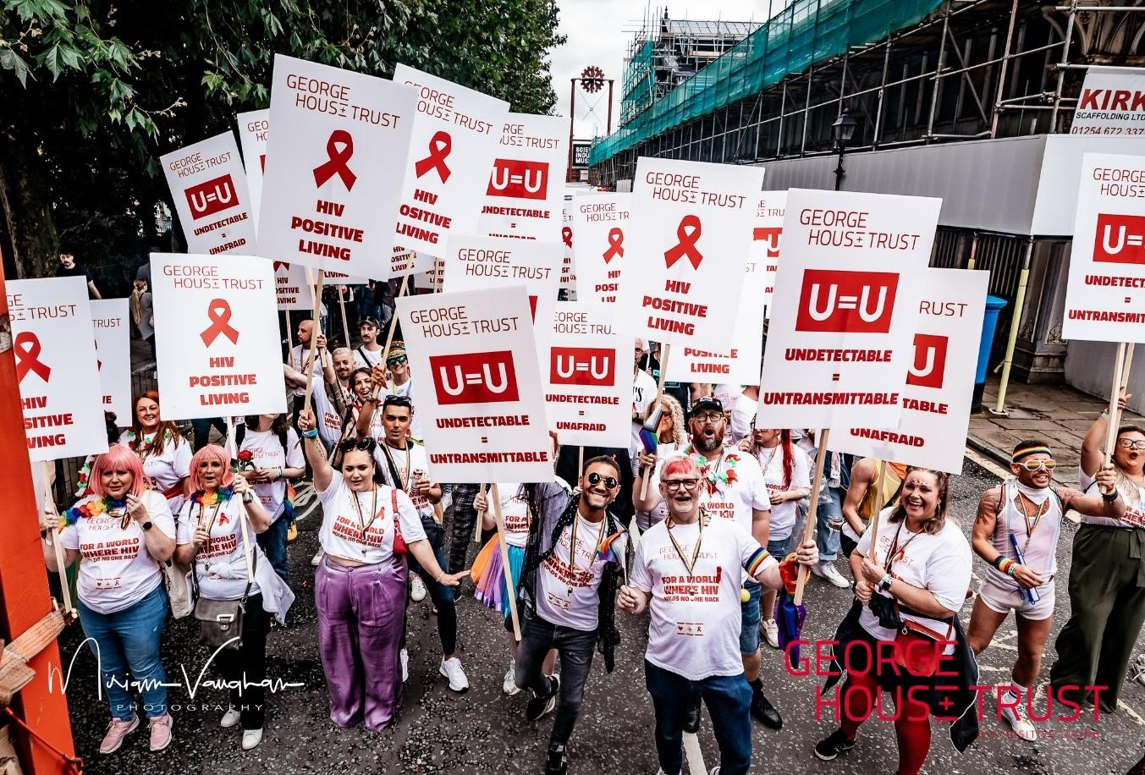Recruitment Pack:

Ageing Well Officer (Liverpool)

March 2024

Ageing Well is generously funded by The National Lottery Community Fund.

Introduction
George House Trust is a charity with a clear vision for a world where HIV holds no-one back. Originally established in 1985 as Manchester AIDS Line, we’ve evolved over the years and we now provide support to over 2,500 people each year.

As a result of effective treatment people are living into older age and we want all people living with HIV to age well, and with confidence.

We are now expanding our support for people over the age of 50 who are living with HIV and we’re recruiting for an Ageing Well Officer who will be based in Liverpool to join our Ageing Well team.

We’ve got big ambitions and a lot of work to do. Our staff are supported by a passionate volunteer team. It’s fair to say that no two days are the same at George House Trust.

Whilst it is not an essential criteria for the role, we always actively encourage applications from people living with HIV.

This recruitment pack provides a summary of who we are, what we do and the details of the Ageing Well Officer role, together with the role description, person specification and details of how to apply.

A message from the Chief Executive…
Expanding our offer for people who are aged 50+ is a key objective for George House Trust. We want everyone living with HIV to live healthy and confident lives and we know that for people ageing with HIV, that can sometimes mean that they need some extra support. We’ve designed our Ageing Well programme with people living with HIV to ensure that people have access to the best support possible. This new role in our Ageing Well team will enable us to reach more people and deliver more creative support and solutions for people to live well and I wish you the best of luck with your application.

Who we support
George House Trust supports people living with and affected by HIV. Young, old, newly diagnosed or living with HIV since the early 1980s, our team is wholly focused on person-centred and individual outcomes, together with enabling peer-led services and support. Our work also includes supporting partners, families, friends and colleagues impacted by HIV.

What we do
Our organisational purpose is ‘inspiring people living with HIV to live healthy and confident lives’. At George House Trust, we provide more than 30 different services spanning everything from wellbeing, welfare and financial support. A big focus of our work is on supporting people with a range of different issues relating to HIV including ageing well, addressing issues relating to housing, supporting people with complex lives, tackling vulnerability, inequality and promoting inclusion.

Why we do it
George House Trust believes that people should have the support, information, advice and guidance that they need to live well with HIV. Everyday, we see people who face discrimination, some are living in fear and most are managing the consequence of structural and societal stigma that is unique to HIV as a health condition. We see our role as the support service to enable people to realise their potential and focus on HIV positive living.

Where we work
Our work is predominantly delivered in the North West region of England, with staff located in Greater Manchester and in Liverpool.

Our strategy
The strategic priority for George House Trust is to ‘Ensure our work meets the changing needs of people living with HIV’. There are 4 strategic objectives that shape all that we do:
- We will increase our reach.
- We will provide quality services.
- We will involve more people living with HIV.
- We will improve the way we do things.

The purpose, vision and values of George House Trust drive the organisation’s strategy, focus and service delivery and are as follows:

George House Trust’s vision is:
A world where HIV holds no one back.

George House Trust’s purpose is:
Inspiring people living with HIV to live healthy and confident lives.

George House Trust has three organisational values which are:
Passionate. Inclusive. Responsive.

The way we work
George House Trust encourages accountability, individuality, and flexibility in our team. We want our people to have ideas and turn them into actions. We bring the team together regularly to explore ideas and share learning through team meetings, development workshops and externally facilitated workshops too.

Personal development is important to us too. We encourage people to learn and in addition to providing an individual training budget for all staff, we actively encourage opportunities for colleagues to get involved in external partnerships that develop learning and networks.

The benefits of working at George House Trust
We offer an excellent employee benefits package which includes:
- an individualised approach to flexible working.
- an 8% non-contributory pension scheme.
- an employee assistance package (including free-to-access counselling).
- a cycle to work scheme.
- a dedicated training budget for each employee.
- full remote digital access to enable agile working.
- generous annual leave plus 8 bank holidays plus additional days at Christmas.
- …plus, many other benefits.

The team
We currently employ 21 people and we’re supported by 133 volunteers. We are led by a board of 9 trustees who bring a blend of skills, experience and passion to the strategic leadership and governance of the charity. As a user-led organisation, George House Trust has a Membership structure with over 160 Members who are people living with HIV, allies and supporters.

How to apply
Please apply in writing in MS Word format [please don’t PDF your application] stating, in no more than 2,000 words, how you meet the ‘application’ criteria in the Person Specification together with an up-to-date copy of your C.V.
Please also complete and submit our demographic monitoring form which you can find here. The form will be stored separately from your application and will not be used as part of the shortlisting process.
Email your completed application and C.V. to recruitment@ght.org.uk by 5pm on Friday 29th March 2024.

Interviews will be held on Monday 8th April 2024.

If you have any questions about this role or the application process, contact Anna Hughes, Ageing Well Programme Coordinator, in the first instance via email – anna@ght.org.uk - who will be happy to organise an informal conversation.

Role Description
Job Title: | Ageing Well Officer
Hours: | 14 hours per week (0.4 FTE)
Contract: | Fixed term contract to end January 2027
Salary: | NJC SCP 10 £25,545 (0.4 FTE - £10,218).
Location: | Liverpool, with occasional travel to Manchester
Accountable to: | Programme Coordinator - Ageing Well Project

Purpose of the role
To grow and develop partnerships and relationships across Liverpool to strengthen the offer for people ageing with HIV and to connect people aged 50+ to support, activities and groups.

Principle responsibilities
1. | To signpost and refer people who are 50+ and living with HIV to relevant support and services, both internally and externally.
2. | To identify other VCSE sector organisations in the Liverpool to provide a range of local support to older people living with HIV.
3. | To plan, schedule and facilitate group events and information sessions for people aged 50+ who are living with HIV.
4. | To plan and co-deliver HIV awareness training sessions to organisations working with people aged 50+ and to offer follow-up support and information following training.
5. | To identify opportunities to deliver HIV awareness training sessions.

Additional responsibilities
- To work as part of the wider team at George House Trust, participating in staff team meetings and act in accordance with agreed office practices and systems.
- To carry out tasks in line with George House Trust’s policies and uphold these at all times.
- To always respect and maintain confidentiality.
- To carry out other work appropriate to the level and nature of the post, as agreed by the organisation in response to the changing needs and circumstances.
- To work with the Volunteer Manager to coordinate volunteer support for service users who are experiencing isolation, loneliness and frailty.
- To support the Programme Coordinator in the wider delivery of the project.

This acts as the selection criteria and the more of the criteria that you demonstrate that you are able to meet the greater your likelihood of being invited to interview, although you do not need to meet all the selection criteria to apply for this role.
We’re specifically looking for you to identify how you meet the criteria marked as ‘A = Application’ at the initial stage application. We’ll look for others as marked below.
A = Application I = Interview P = Presentation

Experience |  | Criteria
E1. | Experience of facilitating group sessions. | A
E2. | Experience of delivering training sessions. | A
E3. | Experience of working with volunteers. | A

Skills |  | Criteria
S1. | Demonstrable presentation skills. | I, P
S2. | Excellent written and verbal communication skills. | A, I
S3. | Excellent interpersonal skills. | A, I
S4. | The ability to plan and prioritise. | A
S5. | The ability to work on own initiative. | A, P
S6. | The ability to maintain confidentiality. | A, I
S7. | Good Microsoft Office skills, including Word, Excel, PowerPoint and Outlook. | A, P

Knowledge |  | Criteria
K1. | A good knowledge of VCSE sector organisations in Liverpool. | A, I
K1. | A clear understanding of HIV, including HIV stigma and discrimination. | A, I, P
K2. | An understanding of the issues faced by people who are ageing with HIV. | A, I, P
K3. | An understanding of safeguarding, including responding to safeguarding situations. | A, I

Personal attributes and approach |  | Criteria
P1. | A commitment to improving your own knowledge and skills. | I
P2. | A commitment to George House Trust’s mission, vision and values and embracing them within your work. | A, I
P3. | A commitment to equality, diversity and inclusion and challenging discrimination. | A, I

George House Trust will consider any reasonable adjustments requested by applicants with a disability (as defined under the Equality Act 2010) who meet the requirements of the post to be invited to interview, in line with the Disability Confident scheme.

Disclosure and Barring Service (DBS)
This post will require an appropriate level DBS check.

George House Trust ght.org.uk 0330 174 4433
info@ght.org.uk

Charity Number: 1143138
Company Number: 0757537

