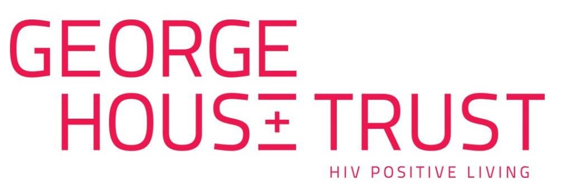

External Evaluator – Ageing Well

March 2024

Ageing Well is generously funded by The National Lottery Community Fund.

Invitation to Tender
Ageing Well Project External Evaluation

Introduction
George House Trust is a charity with a clear vision for a world where HIV holds no-one back. Originally established in 1985 as Manchester AIDS Line, we’ve evolved over the years and we now provide support to over 2,500 people each year. As a result of effective treatment people are living into older age and we want all people living with HIV to age well, and with confidence.

We are now expanding our support for people over the age of 50 who are living with HIV and we are looking for an External Evaluator contractor to provide an in-depth analysis of our Ageing Well project.

Commissioning Organisation: George House Trust

Project Duration: February 2024 – February 2027

Contract Term: April 2024 – February 2027

Contract Value: £3,750 in total (£1,250 per year)

Contract Type: Self-employed contractor, engaged on a ‘contract for services’ basis

Location: Greater Manchester

Evaluation Overview
George House Trust is looking to work with an External Evaluator to provide an in-depth analysis of our Ageing Well project.
We want the evaluation to:
- Evidence the direct and indirect benefits of providing the Ageing Well project for older people living with HIV.
- Inform future service provision within George House Trust.
- Demonstrate the impact of George House Trust providing the Ageing Well service.
- Strengthen our chances of securing future funding, as well as attracting new partners.
About the Ageing Well Project
Ageing Well is a three-year project, funded by the National Lottery Community Fund and is a development of our established Age+ project. Ageing Well will build on our existing support to empower people aged 50+, who are living with HIV, to live healthy and confident lives now, and into older age.
Envisaged outcomes from the project would be that people aged 50+ who are living with HIV would report:
- Improved overall wellbeing.
- Improved emotional health and wellbeing.
- Increased connectivity and reduced feelings of isolation.
- Increased confidence in ageing.
- Increased confidence to manage HIV.
- Increased involvement in volunteering activities.
The project will also continue to offer HIV awareness training to residential and domiciliary care providers and organisations working with older people, with the aim to;
- Increase knowledge and understanding of staff.
- Increase shared learning amongst organisations providing support to people aged 50 and living with HIV.
Target numbers of beneficiaries and interventions will also be set for the project and will be reported on as part of the evaluation.
The essential outputs will be;
As a minimum, we expect the External Evaluator to meet the following deliverables:
- To establish a robust evaluation framework by May 2024.
- To undertake and complete overall evaluation and project reports available in March 2025, March 2026 and a final report in February 2027.

The successful candidate will also be required to attend quarterly Project Advisory Group meetings here at George House Trust.
We expect the Evaluator to share findings with the Ageing Well Programme Coordinator and to keep them abreast of any developments.
For each evaluation we would expect as a minimum:
- Analysis of project outcomes data.
- The use of other relevant creative approaches to gathering feedback with project beneficiaries.
- The delivery of focus groups and one-to-one interviews with the following groups:
  - People aged 50+ and living with HIV
  - George House Trust paid staff
  - Activity facilitators and speakers
  - External partners
Submission Outline
Email us a submission of no more than 2 sides of A4 (excluding any examples of past work) to anna@ght.org.uk
Tell us about:
- Your interest in this particular piece of work.
- Your track record.
- How you propose to meet this brief.
- Your proposed processes and methodology for information gathering and analysis.
- Who you would involve and how you would ensure high stakeholder engagement.
- Any other relevant information.

Please also enclose examples of past work as well as the names of two referees. These should be current or recent clients for whom similar evaluations were carried out.

Key Dates

Deadline for submissions | Monday 8th April 2024 – 5.00pm
Interviews for shortlisted candidates | Friday 12th April 2024

Contact Details
If you would like additional information or have any questions, please contact Anna Hughes, Ageing Well Programme Coordinator via email: anna@ght.org.uk

Data Protection
Please note that you will be expected to work within George House Trust’s Policies, including our Data Protection Policy and Confidentiality Policy. Any data you collect as part of this evaluation work will be owned by George House Trust

George House Trust is a Registered Charity in England and Wales (reg. no. 1143138) & a Registered Company Limited by Guarantee in England and Wales (reg. no. 07575379) Registered Office 75-77 Ardwick Green North, Manchester M12 6FX.

